Design of Wearable Device for Child Safety
Aim:
Aim of the project is to develop a wearable device for Child safety within a child care environment such as playschool or any other educational institutions. This device should be able to track the location of students by teacher or care take with the help of sensor nodes installed within the school. After school time, child should be handover only to the facially verified parent/ guardian.
Abstract:
Daycare/ Educational institutions are great environment for children to gain more knowledge and have fun. Those institutions are not act like usual schools; here tracking of child location is quite difficult to caretaker or teacher. Our proposed system will simplify this process by adopting RFID technology. N numbers of RFID readers were installed around the buildings. Child will have the wrist band with RFID tag, whenever he cross the RFID reader his current position will automatically detected and updated to the cloud. Cloud database maintain the records of child’s moving history around the building by date wise and the current location. Care taker/ Teacher having the customized mobile application to view the child’s location history and location. This application fetches the data from cloud database and display in a list view. At the time child/ student leaving from school, his parent or guardian will be verified by face recognition system. Institution has the photo of parent of child and it will feed to the database of face recognition system. This system will extract the facial futures using CNN algorithm and build the face recognition model. This can be used to classify the live faces coming from webcam. Once the person identified as a parent of that student he will be handover by caretaker. If the person who came to pick up the child is not successfully verified by the system, it will send the alert message to registered parent’s mail id.
Existing System:
When the children wearing this device, the various sensors such as Heart beat sensor, MEMS, Temperature and Humidity sensor will sense the respective values and give it to the microcontroller. Based on the threshold values of heart beat rate, surrounding temperature and humidity, the controller will compare and real values. And by using IOT the same will be updated in the cloud server in return to the mobile application.
Proposed System:
Proposed system used to track the child location within the closed environment such as play school or daycare systems. In this method child need not to wear any complex electronic device. Here, a simple wrist band with RFID tag will be provided to track the location of child. Sensor nodes installed around the building will identify the location of child within institution.

Block Diagram:
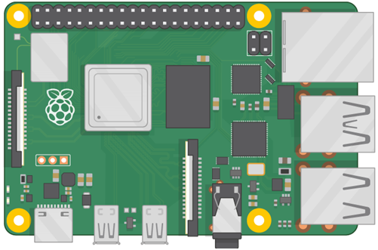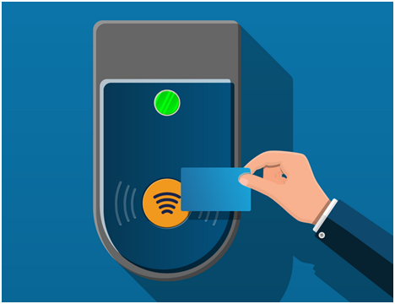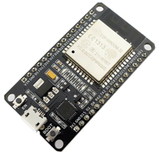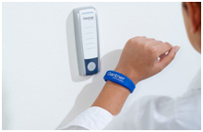
RFID Reader
RFID Reader
Webcam
Raspberry Pi
Parent/ Guardian
Child with Tag
Cloud Database
ESP32
Teacher
Student List

Hardware Requirements:
- Raspberry Pi
- ESP32
- RFID Reader (EM-18) *2
- USB camera
- RFID Tag *3
- LCD Display
Software Requirements:
- ESP-IDF tool
- Android Studio

